First Destination Report
2020 Graduates
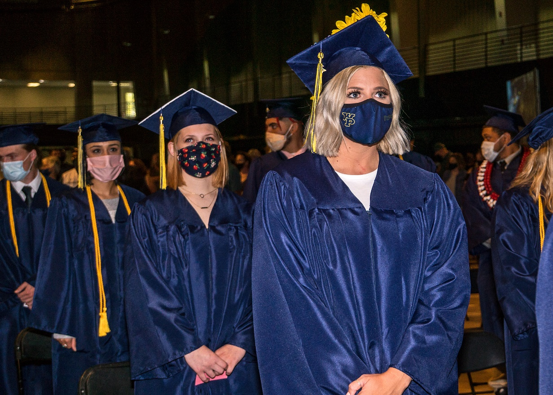

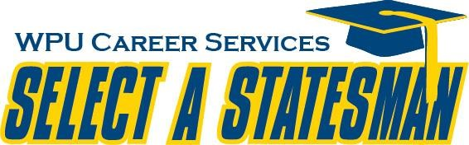

William Penn University
Oskaloosa, IA
Class of 2020 Respondents/Overview
CLASS OF 2020

The Career Services Office collects information from graduating students twice a year – from December graduates and from May graduates. A survey is used, and is sent to all graduating students identified by the Registrar. This information is for the Class of 2020, collected between September 1, 2019 and August 30, 2020. The information provided for this report is based on responses from 179 students out of a class of 213 students in 2020, for a response rate of 84%. Additional information regarding employment by division is included in this report.
Graduates
Total Number of Graduates 213 |  | 100%
Respondents to Surveys 179 |  | 84%
Unknown 34  Employment (% of 179 Respondents) |  | 16%
Employed 95 |  | 53% *
Not Seeking Employment 7 |  | 4% *
No Formulated Employment Plans 41 |  | 23% *
Planning to Continue Education 33 |  | 19% *

EMPLOYMENT BY DIVISION

This section identifies employment by division for Applied Technology, Business Administration, Education, Health and Life Sciences, Humanities, Nursing, Interdisciplinary Studies, and Social and Behavioral Sciences. The graduates in these divisions have earned a Bachelor’s degree. A breakdown of respondents in the Master of Business Leadership program is also included.

Applied Technology Division

Sixteen graduates from the Applied Technology Division, with majors in Applied Math, Industrial Technology, Computer Science, Information Technology, and Software Engineering, responded to the survey. Ten provided employment information and one provided continuing education information.

Employment Highlights

General Motors | Intern | Wentzville | MO
Walmart |  | Oskaloosa | Iowa
Musco Sports Lighting | Intern in Engineering | Oskaloosa | IA
Walmart
Walmart
Campaign Headquarters | Data Management Specialist | Brooklyn | IA
Walmart
William Penn University | Software Engineer |  | MN
PPI | IT specialist | Pella | IA
Walmart

Continuing Education Highlights (Institution, Program, Degree, City & State)

William Penn University | Business Leadership | MBL | Oskaloosa | IA

Please Note: Blank spaces in the tables throughout this report indicate no information was provided. Some respondents who indicate they are employed or continuing their education provide no information or incomplete information.

Business Administration Division

Twenty-two graduates from the Business Administration Division, with majors in Business Management, Accounting, and Human Resource Management responded to the survey. Thirteen provided employment information. Five graduates in this division shared the intent to seek additional education at this time, four of them provided continuing education information

Employment Highlights

City of DSM WRA | Administrative Coordinator | Des Moines | IA
Wells Fargo | Business Support Manager | Des Moines | IA
US Department of Agriculture | Farm Bill Specialist | Chariton | IA
Prairie Meadows | Casino Floor Attendant | Altoona | IA
Vaco | Content Analyst | San Francisco | CA
Schneider Electric | Sales Development | Nashville | TN
Enterprise | Manager in Training | Ottumwa | IA
 | Leader teacher
Bankers Trust Company | Customer Service Rep | Des Moines | IA
Maurices, Hy-Vee | Stylist, Floral Designer | Oskaloosa | IA
Geodis | Warehouse worker | Lebanon | TN
DLL Finance LLC | Litigation & Bankruptcy Specialist | Johnston | IA
REG, Renewable Energy Group | Senior Coordinator | Ames | IA
Floyd County Medical Center | Patient Access | Charles City | IA

Continuing Education Highlights (Institution, Program, Degree, City & State)

William Penn University | Business Leadership | MBL | Oskaloosa | IA
William Penn University | Business Leadership | MBL | Oskaloosa | IA
St. Mary’s University TX | _{Business Administration} | MBA | San-Antonio | TX
William Penn University | Business Leadership | MBL | Oskaloosa | IA

Education Division

Forty-eight graduates from the Education Division, with majors in Elementary Education and Secondary
Education, and such endorsements as Special Education, ESL, Reading, and Coaching, responded to the survey. Twenty-nine provided employment information and two indicated plans for continuing education, only one providing information.

Employment Highlights

Smokey Row Coffee Shops, LLC | Shift Manager-Barista | Oskaloosa | IA
Ottumwa High School | High School Math Teacher | Ottumwa | IA
Thorpe Gordon Elementary | 2nd Grade Teacher | Jefferson City | MO
Sigourney Elementary | Title 1 reading & special education teacher | Sigourney | IA
 | Teacher
Davenport Community School District | Paraeducator | Davenport | IA
Storm Lake Elementary School | Storm Lake Elementary | Storm Lake | IA
Indianola high school | Industrial technology teacher |  | IA
Pac Staff/William Penn University | Pac Staff (Supervisor) | Oskaloosa | IA
Nicholson Chiropractor | Chiropractic assistant | Tracy | CA
Ottumwa Christian School | Teacher | Ottumwa | IA
Walmart
Walmart
Walmart | Coach |  | IA
Walmart
Walmart | Special Education Teacher 4-6 | Sigourney | IA
Walmart
Walmart
Walmart | Kindergarten Teacher | Ottumwa | IA
Walmart | Elementary Special Education | Packwood | IA
Oskaloosa Community School District | Special Education teacher | Oskaloosa | IA
Cedar Falls Community School District | Para Educator | Cedar Falls | IA
Burlington Community School District | 7th grade BD teacher | Burlington | IA
Grinnell-Newburg Community School District | Interim Sub for 1st Grade | Grinnell | IA
Dollar General, schools vary | P/T Lead sales associate, substitute teaching | Monroe | IA
Tipton Community School District | Long Term Substitute for first grade | Tipton | IA
Fort Madison Community School District | Special Education Preschool Para Educator | Fort Madison | IA
St. Mary of the Visitation Catholic Church | Director of Religious Education | Ottumwa | IA
Walmart |  | Ottumwa | IA
Continuing Education Highlights (Institution, Program, Degree, City & State)

Morningside College | Strat II | Endorsement | Sioux City | IA

Health & Life Sciences Division

Twenty-six graduates from the Health & Life Sciences Division, with majors in Biology (General and Preprofessional), Sports Administration/Management, Strength & Conditioning, Wellness & Recreation, and Kinesiology, responded to the survey. Thirteen provided employment information and 14 indicated the intention of continuing their education, 11 provide continuing education information

Employment Highlights

City of Broken Arrow | Utilities Worker | Broken Arrow | OK
Wal-Mart | Cap-2 Supervisor | Oskaloosa | IA
William Penn University | graduate assistant coach | Oskaloosa | IA
William Penn University | PAC Worker | Oskaloosa | IA
Mahaska County YMCA | Head Swim Team Coach | Oskaloosa | IA
William Penn University | Graduate Assistant | Oskaloosa | IA
 | Somewhere in the sports field
Marion County Environmental Health | Environmental Health Assistance | Knoxville | IA
 |  |  | KS
Walmart | Medical sales | Springfield | MO
Walmart
William Penn University | GA for Bailey in the PAC
Epic Brewing company |  | Salt Lake City | UT

Continuing Education Highlights (Institution, Program, Degree, City & State)

Palmer College of Chiropractic Florida Campus | Doctorate of Chiropractic | Doctorate of Chiropractic | Port Orange | FL
Keiser University | Physical Therapist Assistant | AS | Fort Lauderdale | FL
Oregon Institute of Technology | Radiology |  | Klamath Fall | OR
William Penn University | Sports Management | MSM | Oskaloosa | IA
William Penn University |  |  | Oskaloosa | IA
William Penn University |  |  | Oskaloosa | IA
William Penn University | Sports Management | MSM | Oskaloosa | IA
William Penn University | Sports Management | MSM | Oskaloosa | IA
William Penn University | Sports Management | MSM | Oskaloosa | IA
William Penn University | Sports Management | MSM | Oskaloosa | IA
Allen College | Medical Laboratory Science | MLS Certification | Waterloo | IA

Humanities Division

Seven graduates from the Humanities Division, with such majors as Communications, Digital Communications, and Music, responded to the survey. Two of Seven provided employment information and no one provided continuing education information.

Employment Highlights

Book Vault | Sales Associate | Oskaloosa | IA
Clow Valve Company |  | Oskaloosa | IA

Nursing Division

One graduate seeking their Bachelors of Science in Nursing responded to the survey. One provided employment information. No graduates in this division shared the intent to seek additional education.

Employment Highlights

Unity Point-Grinnell Regional Home Care and Hospice | RN-Home Health and Hospice Manager | Grinnell | IA

Social & Behavioral Sciences Division

Thirty graduates in the Social & Behavioral Sciences Division, with majors in Sociology, Psychology, Criminology, Human Services, History and Government, responded to the survey. Fourteen indicated employment after graduation, eight indicated continuing with their education, with five providing information.

Employment Highlights

Walmart |  | Bennett | CO
Walmart | Sales | Oskaloosa | IA
Walmart | Patient Access
Cox Medical Center Branson | High school girls’ basketball assistant coach | Branson | MO
 | Floor Clerk
Mecum Auctions | Auction Floor Clerk
Oskaloosa Care Center | Dietary Aide | Oskaloosa | IA
Walmart | Online Shopper | Oskaloosa | IA
William Penn University | Graduate Assistant for Athletic Operations | Oskaloosa | IA
William Penn University | Resident Assistant | Oskaloosa | IA
Homestead of Knoxville | Direct Care Worker-Meds | Knoxville | IA
Imagine the Possibilities | Care Giver | Oskaloosa | IA
 | Correctional officer | West Des Moines | IA
Imagine the Possibilities | DSP | Oskaloosa | IA

Continuing Education Highlights (Institution, Program, Degree, City & State)

Buena Vista University | Professional School Counseling | Masters | Storm Lake | IA
Buena Vista University | Mental Health Counseling | Masters | Storm Lake
Northcentral University | Educational Psychology | Masters | San Diego | CA
William Penn University | Sports Management | MSM | Oskaloosa | IA
Minnesota State University - Mankato | Masters of Sport and Exercise Psychology | Masters | Mankato | MN

Interdisciplinary Studies

An Interdisciplinary Studies Major has been developed. Because the studies may go across Divisions, this information has been pulled out separately for this report. One graduate responded to this survey. One indicated employment after graduation but provided no information

Digital Communication

Five graduates in the Digital Communication Division, with majors in Digital communication responded to the survey. Three indicated employment after graduation.

Employment Highlights

Walmart | Sales associate | Chicago | IL
Walmart | Tour Videographer | Oskaloosa | IA
KBOE/KMZN Radio, Self-Employed | Board Operator/ Freelance Media Producer | Oskaloosa | IA

Master of Business Leadership

Twenty-two MBL graduates responded to the survey. Of those, sixteen indicated employment after graduation; 16 provided information about employment, indicated below.

Employment Highlights

CCUSO | Psychiatric Security Specialist | Cherokee
Sigourney CSD | Special Education Teacher | Sigourney | IA
Pella Corp | Production line | Pella | IA
Enterprise Rent-a-car | Management Trainee | Pella | IA
 | Claims | Manchester | UK
Brethern Church | Pastor |  | IA
William Penn University | Information Systems Specialist | Oskaloosa | IA
The Ohio State University Wexner Medical | Lead Athletic conditioning spec | Ohio | OH
Appalachian State University | Assistant Athletic Performance Coach | Boone | NC
William Penn University | Head women’s volleyball coach | Oskaloosa | IA
Casey's General Stores | District Manager | Remote
William Penn University | Athletic Trainer | Oskaloosa | IA
William Penn University | Instructor of Business Management | Oskaloosa | IA
Shawcor | US Operations Manager | Midland | TX
Rock Valley College | Assistant Men's Basketball Coach | Rockford | IL
Walmart

No MBL candidates indicated pursuing further degrees at this time.

INTERNSHIPS

William Penn University encourages every student to consider completing at least one internship in his/her field of study before graduation. This list is included to share the types of employers supporting William Penn University students by hosting student interns. Many of these employers also hire WPU graduates.

Seventy-five student respondents in the Class of 2020 completed internships. 54 completed one internship; 21 completed two internships. Locations of reported internships are listed, and were in Iowa, Arizona, Maryland, Illinois, and Oklahoma.

Banner Health Phoenix  Baxter Early Learning Center  Bennett Elementary  Cablevey Conveyors  Capital Resources/Campaign Headquarters  Carollo Engineers  Clow Valve Company  College Avenue Friends Church  CASA, Iowa Child Advocacy Board  Crisis Intervention Services  Douglas W. Moore  Homestead Assisted Living  Iowa City School District  KBOE Radio  Mahaska County YMCA  Mahaska Health Partnership Laboratory  Mahaska Health Partnership Physical Therapy  Marion County Naturalist  Mahaska Communication Group (MCG)  Mid-America Publishing Corporation  Montogomery College, Rockville, MD  Moravia Elementary School  Musco Sports Lighting | Mahaska Health Partnership  NoCoast Beer Co.  Oskaloosa Christian School  Ottumwa (City of)  Pence Elementary Fairfield  Solon Elementary  Tipton Elementary  United Way of Mahaska County  Vermeer Corporation  Weiler Inc  William Penn University (WPU) Athletics  WPU Communications Research Institute  WPU Career Services  WPU Success Center  WPU Athletic Dep  WPU Football  WPU Basket ball  WPU Athletic Performance  WPU Activity Center Penn University Game Day Operations  WPU Volleyball  WPU Office of Athletics

